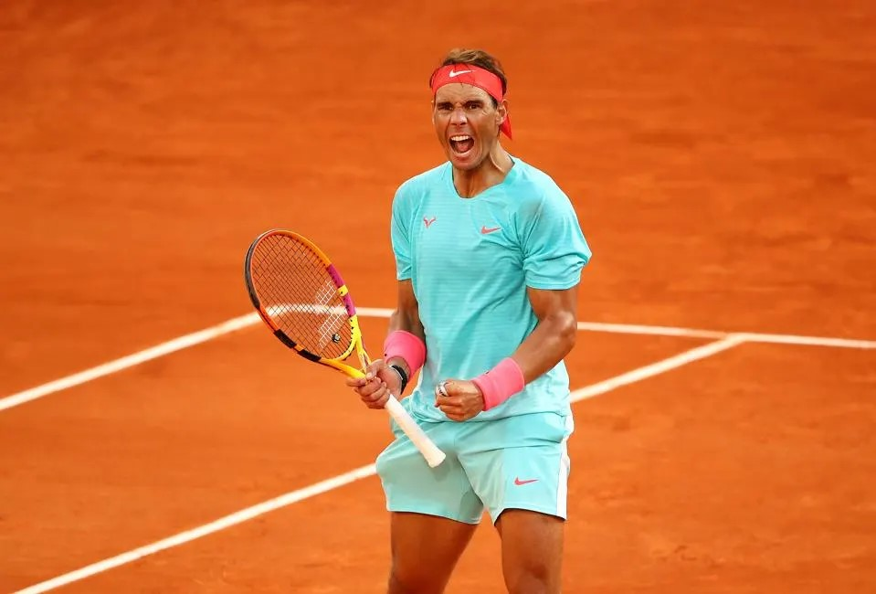

*RAFAEL*

*NADAL*

*3.97*

***GPA***

*5700 Saddlebrook Way | Wesley Chapel, FL 33543*

*813-555-5555 |* *rafaelnadal@atptour.com* *|* [*Recruiting Video/Profile*](https://www.youtube.com/watch?v=J6UBWD8ners&t=10s)

*EDUCATION*

*1200*

***SAT***

Most Recent School, City, State 2023-Present

Class of 20xx

Previous School, City, State 20xx-2023

*1.7*

***WTN***

*14.33*

***UTR***

*TOURNAMENT SCHEDULE*

Saddlebrook L5 9-2023 Quarterfinals

.

.

.

.

.

.

.

.

.

*TENNIS HIGHLIGHTS*

12/2022 Champion, Hunter’s Green L5

.

.

.

.

*AWARDS, ACHIEVEMENTS, & ACTIVITIES*

9/2023 High Honor Roll

*6’1”*

***HEIGHT***

.9/2023 Ball Kid; ITF M25 Wesley Chapel

.

.

.

*ATTRIBUTE 1*

*ATTRIBUTE 2*

*ATTRIBUTE 3*

***ATTRIBUTES***

*3/27/05*

***DOB***

*REFERENCES*

Coach Alvaro Betancur, Saddlebrook Tennis Academy

813-555-5555 | alvaro.betancur@pyramidglobal.com

*EQUIPMENT*

***EQUIPMENT***

Coach Rick Crockett, Saddlebrook Tennis Academy

813-555-5555 | charles.crockett@pyramidglobal.com



*RAFAEL*

*NADAL*

*1.7*

***WTN***

*14.33*

***UTR***

*3.97*

***GPA***

*1200*

***SAT***

*3/27/2005*

***DOB***

*6’1”*

***HEIGHT***

*ATTRIBUTE 1*

*ATTRIBUTE 2*

*ATTRIBUTE 3*

***ATTRIBUTES***

*EQUIPMENT*

***EQUIPMENT***

*5700 Saddlebrook Way | Wesley Chapel, FL 33543*

*813-555-5555 |* *rafaelnadal@atptour.com* *| Recruiting Video/Profile*

*EDUCATION*

Most Recent School, City, State 2023-Present

Class of 20xx

Previous School, City, State 20xx-2023

*TOURNAMENT SCHEDULE*

Saddlebrook L5 9-2023 Quarterfinals

.

.

.

.

.

.

.

.

.

*TENNIS HIGHLIGHTS*

12/2022 Champion, Hunter’s Green L5

.

.

.

.

*AWARDS, ACHIEVEMENTS, AND ACTIVITIES*

9/2023 High Honor Roll

9/2023 Ball Kid, ITF M25 Wesley Chapel

.

.

.

*REFERENCES*

Alvaro Betancur, Coach, Saddlebrook Tennis Academy

813-555-5555 | alvaro.betancur@pyramidglobal.com

Jane Doe, Teacher, Saddlebrook Preparatory School

813-555-5555 | jdoe@saddlebrook.com

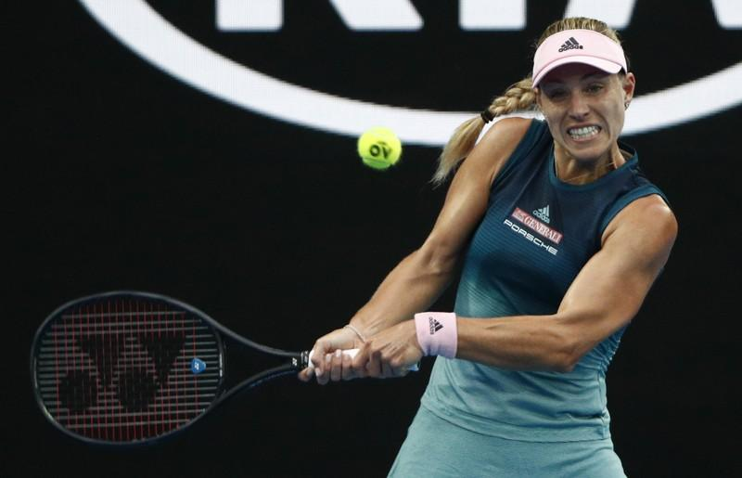

*5700 Saddlebrook Way, Wesley Chapel, FL 33543 | 813-555-5555 |* [*akerber@wta.com*](mailto:akerber@wta.com)*|* [*Video Link*](https://www.youtube.com/watch?v=J6UBWD8ners&t=10s)

*ANGELIQUE KERBER*

*GPA*

*3.97*

*SAT*

*1200*

*WTN*

*1.7*

*UTR*

*12.6*

*DoB*

*3/27/2005*

*Height*

*5’7”*

*Attributes*

*Attribute 1*

*Attribute 2*

*Attribute 3*

*Equipment*

*Babolat*

*Education*

Saddlebrook Preparatory School, Wesley Chapel, FL 2017-Present

Class of 2023

Previous School, Somewhere, In the World 2016-2017

*Tournament Schedule*

Junior Orange Bowl 12/2019 2nd Rd. MD

Eddie Herr 11/2019 4th Rd. MD

Saddlebrook L6 11/2019 Champion

Seminole Lake L6 10/2019 Finalist

Altamonte Springs G5 9/2019 Semifinalist

Saddlebrook L7 9/2019 Quarterfinalist

.

.

.

.

*Tennis Highlights*

12/2022 Champion, Hunter’s Green L5

.

.

*Awards and Achievements*

Student of the Month 10/2019 & 12/2020

National Honor Society 2019-Present

Dean’s List 6/2017, 1/2018 & 6/2018

Saddlebrook Tennis Academy: Hardest Worker 6/2018

Outstanding Student: Computer Applications 6/2018

*References*

Alvaro Betancur, Coach, Saddlebrook Tennis Academy

813-555-5555 | alvaro.betancur@pyramidglobal.com

Jane Doe, Teacher, Saddlebrook Preparatory School

813-555-5555 | jdoe@saddlebrook.com



*ANGELIQUE KERBER*

*5700 Saddlebrook Way, Wesley Chapel, FL 33543 | 813-555-5555 |* [*akerber@wta.com*](mailto:akerber@wta.com)*|* [*Video Link*](https://www.youtube.com/watch?v=J6UBWD8ners&t=10s)



*GPA*

*3.97*

*SAT*

*1200*

*WTN*

*1.7*

*UTR*

*12.6*

*DoB*

*3/27/2005*

*Height*

*5’7”*

*Attributes*

*Attribute 1*

*Attribute 2*

*Attribute 3*

*Equipment*

*Babolat*

*Education*

Saddlebrook Preparatory School, Wesley Chapel, FL 2017-Present

Class of 2023

Previous School, Somewhere, In the World 2016-2017

*Tournament Schedule*

Junior Orange Bowl 12/2019 2nd Rd. MD

Eddie Herr 11/2019 4th Rd. MD

Saddlebrook L6 11/2019 Champion

Seminole Lake L6 10/2019 Finalist

Altamonte Springs G5 9/2019 Semifinalist

Saddlebrook L7 9/2019 Quarterfinalist

.

.

.

.

*Tennis Highlights*

12/2022 Champion, Hunter’s Green L5

.

.

*Awards and Achievements*

Student of the Month 10/2019 & 12/2020

National Honor Society 2019-Present

Dean’s List 6/2017, 1/2018 & 6/2018

Saddlebrook Tennis Academy: Hardest Worker 6/2018

Outstanding Student: Computer Applications 6/2018

*References*

Alvaro Betancur, Coach, Saddlebrook Tennis Academy

813-555-5555 | alvaro.betancur@pyramidglobal.com

Jane Doe, Teacher, Saddlebrook Preparatory School

813-555-5555 | jdoe@saddlebrook.com

Angelique

Kerber

Bremen, Germany

5700 Saddlebrook Way, Wesley Chapel, FL 33543

813-555-5555 | [akerber@wta.com](mailto:akerber@wta.com) | Video Link

*Class of*

*2023*

*GPA*

*3.97*

*SAT*

*1200*

*WTN*

*1.7*

*UTR*

*12.6*

*DoB*

*3/27/2005*

*Height*

*5’7”*

*Attributes*

*attribute 1*

*attribute 2*

*attribute 3*

*Equipment*

*Babolat*

*Education*

Saddlebrook Preparatory School, Wesley Chapel, FL 2017-Present

Previous School, Somewhere, In the World 2016-2017

*Tournament Schedule*

***Tournament Date Result***

Junior Orange Bowl December 2019 2nd Rd. MD

Eddie Herr November 2019 4th Rd. MD

Saddlebrook L6 November 2019 Champion

Seminole Lake L6 October 2019 Finalist

Altamonte Springs G5 September 2019 Semifinalist

Saddlebrook L7 September 2019 Quarterfinalist

.

.

.

.

*Highlights*

S

.

.

*Awards, Achievements, AND ACTIVITIES*

Student of the Month October 2019

Student of the Month Nominee September 2019

National Honor Society 2019-Present

Dean’s List Fall & Spring 2018

Saddlebrook Tennis Academy: Hardest Worker 2018

Outstanding Student: Computer Applications 2018

Dean’s List Spring 2017

*References*

Alvaro Betancur, Coach, Saddlebrook Tennis Academy

813-555-5555 | alvaro.betancur@pyramidglobal.com

Jane Doe, Teacher, Saddlebrook Preparatory School

813-555-5555 | jdoe@saddlebrook.com

TIGERWOODS



5700 Saddlebrook Way | Wesley Chapel, FL 33543 | 813-555-5555 | [yourname@domain.com](mailto:yourname@domain.com) | [Swing Video](https://www.youtube.com/watch?v=J6UBWD8ners&t=10s)

Education

Saddlebrook Preparatory School , Wesley Chapel, FL 2017-Present

Class of 2023

Previous School, Somewhere, In the World 2016-2017

Tournament Schedule

GPA

3.97

SAT

1200

WAGR/AJGA RANKING

100

SCORING AVERAGE

73.5

DRIVE DISTANCE (CARRY)

295 YARDS

DATE OF BIRTH

3/27/2005

HEIGHT

5’10”

ATTRIBUTES

ATTRIBUTE 1

ATTRIBUTE 2

ATTRIBUTE 3

EQUIPMENT

TAYLOR MADE

TOURNAMENT COURSE SCORES RESULT

2020 Innisbrook Jr. Open Copperhead 72-71-73 T-2

2019 HJGT at Saddlebrook Palmer 70-74-72 3

2018 AJGA Senior Showcase @ Saddlebrook Saddlebrook 71-71-71 T-4

2017 Holiday Classic at Orange County Nat’l National 72-71-70 1

.

.

.

.

.

.

Golf HIghlights

Champion, HJGT at Saddlebrook 10/2019

.

.

Awards, Achievements, and Activities

Student of the Month 10/2019 & 12/2020

National Honor Society 2019-Present

Dean’s List 6/2017, 1/2018 & 6/2018

Saddlebrook Tennis Academy: Hardest Worker 6/2018

Outstanding Student: Computer Applications 6/2018

references

Mark Hirschey, Coach, Saddlebrook Golf Academy

813-555-5555 | mark.hirschey@pyramidglobal.com

Jane Doe, Teacher, Saddlebrook Preparatory School

813-555-5555 | jdoe@saddlebrook.com

TIGER WOODS

CLASS OF 2023

**Education**

GPA

3.97

SAT

1200

WAGR/AJGA RANKING

100

SCORING AVERAGE

75.3

DRIVE DISTANCE (CARRY)

295 YARDS

DATE OF BIRTH

3/27/2005

HEIGHT

5’10”

ATTRIBUTES

ATTRIBUTE 1

ATTRIBUTE 2

ATTRIBUTE 3

EQUIPMENT

CALLAWAY

Saddlebrook Preparatory School, Wesley Chapel, FL 2017-Present

Previous School, Somewhere, In the World 2016-2017

**Tournament Schedule**

TOURNAMENT COURSE SCORES RESULT

2020 Innisbrook Jr. Open Copperhead 72-71-73 T-2

2019 HJGT at Saddlebrook Palmer 70-74-72 3

2018 AJGA Senior Showcase @ Saddlebrook Saddlebrook 71-71-71 T-4

2017 Holiday Classic at Orange County Nat’l National 72-71-70 1

.

.

.

.

.

.

**Golf Highlights**

S

.

.

**Awards, Achievements, and Activities**

Student of the Month October 2019

Student of the Month Nominee September 2019

National Honor Society 2019-Present

Dean’s List Fall and Spring 2018

Saddlebrook Tennis Academy: Hardest Worker 2018

Outstanding Student: Computer Applications 2018

Dean’s List Spring 2017

**References**

Mark Hirschey, Coach, Saddlebrook Golf Academy

813-555-5555 | mark.hirschey@pyramidglobal.com

Jane Doe, Teacher, Saddlebrook Preparatory School

813-555-5555 | jdoe@saddlebrook.com

5700 Saddlebrook Way | Wesley Chapel, FL 33544 | 813-555-5555 | yourname@domain.com | Swing Video

Paula Creamer

5700 Saddlebrook Way | Wesley Chapel, FL 33543

813-555-5555 | [yourname@domain.com](mailto:yourname@domain.com) | Swing Video

Education

Saddlebrook Preparatory School, Wesley Chapel, FL 2017-Present

Class of 2023

GPA

3.97

SAT

1200

WAGR/AJGA RANKING

100

SCORING AVERAGE

75.3

DRIVE DISTANCE (CARRY)

295 YARDS

DATE OF BIRTH

3/27/2005

HEIGHT

5’10”

ATTRIBUTES

ATTRIBUTE 1

ATTRIBUTE 2

ATTRIBUTE 3

EQUIPMENT

CALLAWAY

Previous School, Somewhere, In the World 2016-2017

Tournament Schedule

TOURNAMENT COURSE SCORES RESULT

2020 Innisbrook Jr. Open Copperhead 72-71-73 T-2

2019 HJGT at Saddlebrook Palmer 70-74-72 3

2018 AJGA Senior Showcase @ Saddlebrook Saddlebrook 71-71-71 T-4

2017 Holiday Classic at Orange County Nat’l National 72-71-70 1

.

.

.

.

.

.

Golf Highlights

Champion, HJGT at Saddlebrook October 2020

.

.

Awards, Achievements, and Activities

Student of the Month October 2019

Student of the Month Nominee September 2019

National Honor Society 2019-Present

Dean’s List Fall and Spring 2018

Saddlebrook Tennis Academy: Hardest Worker 2018

Outstanding Student: Computer Applications 2018

Dean’s List Spring 2017

References

Mark Hirschey, Coach, Saddlebrook Golf Academy

813-555-5555 | mark.hirschey@pyramidglobal.com

Jane Doe, Teacher, Saddlebrook Preparatory School

813-555-5555 | jdoe@saddlebrook.com

TIGERWOODS



5700 Saddlebrook Way • Wesley Chapel, FL 33544 • 813-555-5555 • [yourname@domain.com](mailto:yourname@domain.com)

ePortfolio Link

Education

Saddlebrook Preparatory School , Wesley Chapel, FL 2017-Present

Class of 2023

GPA: 4.0 SAT Reading: 800 SAT Math: 800 ACT: 36

Previous School, Somewhere, In the World 2016-2017

Tournament Schedule

TOURNAMENT COURSE SCORES RESULT

Saddlebrook Golf Academy

18 years old

1/1/2002

6’1” 187 lbs.

Right-handed

Scoring Average

Drive Average

Coach Mark Hershey

*email*

2020 Innisbrook Jr. Open Copperhead 72-71-73 T-2

2019 HJGT at Saddlebrook Palmer 70-74-72 3

2018 AJGA Senior Showcase @ Saddlebrook Saddlebrook 71-71-71 T-4

2017 Holiday Classic at Orange County Nat’l National 72-71-70 1

Awards and Achievements

Student of the Month October 2019

Student of the Month Nominee September 2019

National Honor Society 2019-Present

Dean’s List Fall and Spring 2018

Saddlebrook Tennis Academy: Hardest Worker 2018

Outstanding Student: Computer Applications 2018

Dean’s List Spring 2017



TIGER WOODS

CLASS OF 2023

DoB: 1/1/2002, 18 years old

6’1” 187 lbs.

Right-handed

Scoring Average

Drive Average

Coach Mark Hershey *email*

**Education**

Saddlebrook Preparatory School, Wesley Chapel, FL 2017-Present

Class of 2023

GPA: 4.0 SAT Reading: 800 SAT Math: 800 ACT: 36

Previous School, Somewhere, In the World 2016-2017

**Tournament Schedule**

TOURNAMENT COURSE SCORES RESULT

2020 Innisbrook Jr. Open Copperhead 72-71-73 T-2

2019 HJGT at Saddlebrook Palmer 70-74-72 3

2018 AJGA Senior Showcase @ Saddlebrook Saddlebrook 71-71-71 T-4

2017 Holiday Classic at Orange County Nat’l National 72-71-70 1

**Awards and Achievements**

Student of the Month October 2019

Student of the Month Nominee September 2019

National Honor Society 2019-Present

Dean’s List Fall and Spring 2018

Saddlebrook Tennis Academy: Hardest Worker 2018

Outstanding Student: Computer Applications 2018

Dean’s List Spring 2017

5700 Saddlebrook Way • Wesley Chapel, FL 33544 • 813-555-5555 • yourname@domain.com

ePortfolio Link

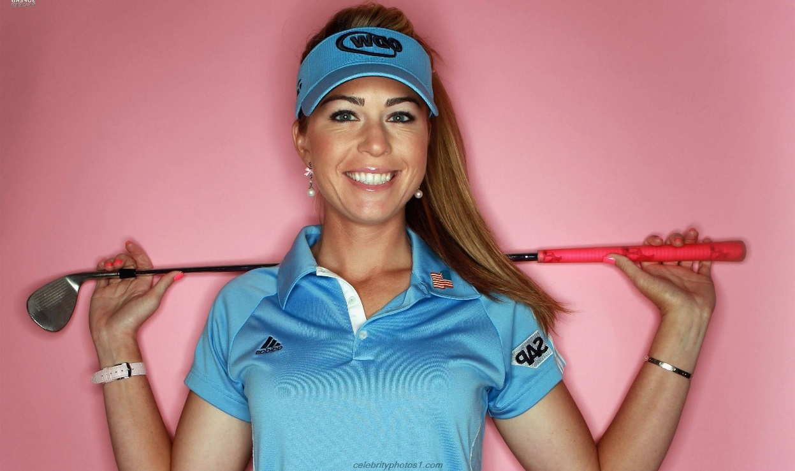

DoB: Jan. 1, 2002; 18 y/o

5’4”

Right-handed

Scoring Average

Drive Average

Coach Mark Hershey *email*

Paula Creamer

5700 Saddlebrook Way • Wesley Chapel, FL 33544 • 813-555-5555

[yourname@domain.com](mailto:yourname@domain.com) • ePortfolio Link

Education

Saddlebrook Preparatory School , Wesley Chapel, FL 2017-Present

Class of 2023

GPA: 4.0 SAT Reading: 800 SAT Math: 800 ACT: 36

Previous School, Somewhere, In the World 2016-2017

Tournament Schedule

TOURNAMENT COURSE SCORES RESULT

2020 Innisbrook Jr. Open Copperhead 72-71-73 T-2

2019 HJGT at Saddlebrook Palmer 70-74-72 3

2018 AJGA Senior Showcase @ Saddlebrook Saddlebrook 71-71-71 T-4

2017 Holiday Classic at Orange County Nat’l National 72-71-70 1

Awards and Achievements

Student of the Month October 2019

Student of the Month Nominee September 2019

National Honor Society 2019-Present

Dean’s List Fall and Spring 2018

Saddlebrook Tennis Academy: Hardest Worker 2018

Outstanding Student: Computer Applications 2018

Dean’s List Spring 2017

Paula Creamer

5700 Saddlebrook Way • Wesley Chapel, FL 33544

813-555-5555 • yourname@domain.com • ePortfolio Link

Education

Quickfacts

DoB: Jan. 1, 2002; 18 y/o

5’4”

Right-handed

Scoring Average

Drive Average

Coach Mark Hershey *email*

Saddlebrook Preparatory School , Wesley Chapel, FL 2017-Present

Class of 2023

GPA: 4.0 SAT Reading: 800 SAT Math: 800 ACT: 36

Previous School, Somewhere, In the World 2016-2017

Tournament Schedule

TOURNAMENT COURSE SCORES RESULT

2020 Innisbrook Jr. Open Copperhead 72-71-73 T-2

2019 HJGT at Saddlebrook Palmer 70-74-72 3

2018 AJGA Senior Showcase @ Saddlebrook Saddlebrook 71-71-71 T-4

2017 Holiday Classic at Orange County Nat’l National 72-71-70 1

Awards and Achievements

Student of the Month October 2019

Student of the Month Nominee September 2019

National Honor Society 2019-Present

Dean’s List Fall and Spring 2018

Saddlebrook Tennis Academy: Hardest Worker 2018

Outstanding Student: Computer Applications 2018

Dean’s List Spring 2017

*surname*

*Given*

*5700 Saddlebrook Way / Wesley Chapel, FL 33543*

*813-555-5555 / rfederer@atptour.com / Recruiting Video*

*5700 Saddlebrook Way Wesley Chapel, FL 33543*

*813-555-5555 rfederer@atptour.com*

*Video Link*

*Class of*

*2023*

*GPA*

*3.97*

*SAT*

*1200*

*WTN*

*1.7*

*UTR*

*12.6*

*DoB*

*3/27/2005*

*Height*

*5’7”*

*Attributes*

*Attribute 1*

*Attribute 2*

*Attribute 3*

*Equipment*

*Wilson*

**/////*Education***

Most Recent High School, City, State 2021-Present

Previous High School, City, State 2019-2021

**/////*Tournaments & Results***

**Date Tournament Surface Result**

8/2022 Saddlebrook L6 Clay Semifinalist

7/2022 Seminole Lake L6 Hard Finalist

7/2022 Sarah Vande Berg Clay Quarterfinalist

6/2022 Altamonte Springs Clay Rd. of 16

5/2022 National Campus Hard Con. Champion

5/2022 ITF Puerto Rico Clay Con. Rd. of 32

4/2022 ITF Monterrey Clay Rd. of 64

4/2022 Naples Celsius UTR Hard Champion

3/2022 Inspiration Academy Hard Semifinalist

2/2022 NextGen Academy UTR Hard Quarterfinalist

**/////*Highlights***

S

**.**

**.**

**/////*Awards & Achievements***

Student of the Month 10/2021

Student of the Month Nominee 9/2021

National Honor Society 2020-Present

Dean’s List Spring 2020

Dean’s List Fall 2020

Saddlebrook Tennis Academy: Hardest Worker 2019

Outstanding Student: Computer Applications 2019

Dean’s List Spring 2019

**/////*References***

Alvaro Betancur, Coach, Saddlebrook Tennis Academy

813-555-5555 | alvaro.betancur@pyramidglobal.com

Jane Doe, Teacher, Saddlebrook Preparatory School

813-555-5555 | jdoe@saddlebrook.com