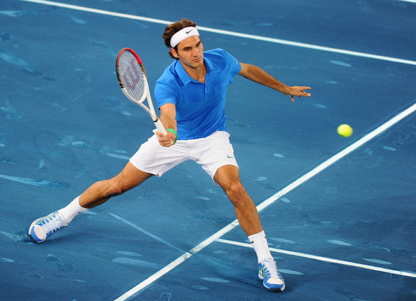
Roger Federer
Saddlebrook Tennis Academy
Right-handed
Highly instinctive, excellent movement, strong forehand
6’1” 187 lbs.
16.21 UTR
Wilson Pro Staff RF 97
Coach Sean McQuillan
email



Education
Saddlebrook Preparatory School, Wesley Chapel, FL 2017-Present
Class of 2023
GPA: 4.0 SAT Reading: 800 SAT Math: 800 ACT: 36

Previous School, Somewhere, In the World 2016-2017

Tournament Schedule
Junior Orange Bowl 2nd Rd. MD December 2019
Eddie Herr 4th Rd. MD November 2019
Saddlebrook L6 Champion November 2019
Seminole Lake L6 Finalist October 2019
Altamonte Springs G5 Semifinalist September 2019
Saddlebrook L7 Quarterfinalist September 2019

Awards and Achievements
Student of the Month October 2019
Student of the Month Nominee September 2019
National Honor Society 2019-Present
Dean’s List Fall and Spring 2018
Saddlebrook Tennis Academy: Hardest Worker 2018
Outstanding Student: Computer Applications 2018
Dean’s List Spring 2017

ROGER FEDERER
6’1”

Education
Saddlebrook Preparatory School, Wesley Chapel, FL 2017-Present
Class of 2023
187LBS

GPA: 4.0 SAT Reading: 800 SAT Math: 800 ACT: 36

Previous School, Somewhere, In the World 2016-2017
Right-handed
Highly instinctive, excellent movement, strong forehand
16.21 UTR
Wilson Pro Staff RF 97

Tournament Schedule
Junior Orange Bowl 2nd Rd. MD December 2019
Eddie Herr 4th Rd. MD November 2019
Saddlebrook L6 Champion November 2019
Seminole Lake L6 Finalist October 2019
Altamonte Springs G5 Semifinalist September 2019
Saddlebrook L7 Quarterfinalist September 2019

Awards and Achievements
Student of the Month October 2019
Student of the Month Nominee September 2019
National Honor Society 2019-Present
Dean’s List Fall & Spring 2018
Saddlebrook Tennis Academy: Hardest Worker 2018
Outstanding Student: Computer Applications 2018
Dean’s List Spring 2017


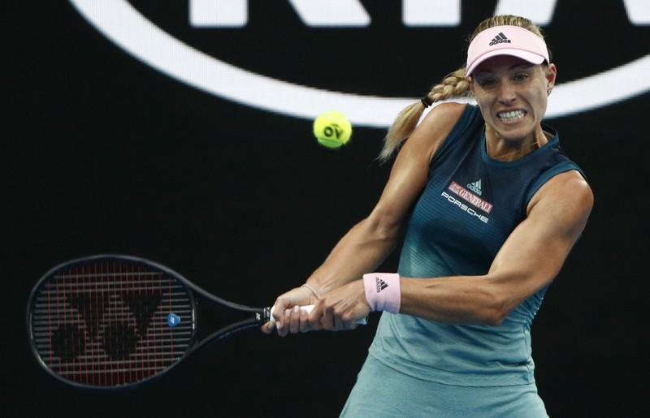

ANGELIQUE KERBER

Measurables
5’8”
Right-handed
Highly instinctive, excellent movement, strong forehand
16.21 UTR
Wilson Pro Staff RF 97
Coach Sean McQuillan
email

Contact
5700 Saddlebrook Way
Wesley Chapel, FL 33543
813-555-5555
yourname@domain.com
ePortfolio Link
Education
Saddlebrook Preparatory School, Wesley Chapel, FL 2017-Present
Class of 2023
GPA: 4.0 SAT Reading: 800 SAT Math: 800 ACT: 36

Previous School, Somewhere, In the World 2016-2017

Tournament Schedule
Junior Orange Bowl 2nd Rd. MD December 2019
Eddie Herr 4th Rd. MD November 2019
Saddlebrook L6 Champion November 2019
Seminole Lake L6 Finalist October 2019
Altamonte Springs G5 Semifinalist September 2019
Saddlebrook L7 Quarterfinalist September 2019

Awards and Achievements
Student of the Month October 2019
Student of the Month Nominee September 2019
National Honor Society 2019-Present
Dean’s List Fall & Spring 2018
Saddlebrook Tennis Academy: Hardest Worker 2018
Outstanding Student: Computer Applications 2018
Dean’s List Spring 2017

Angelique
Kerber

Bremen, Germany

Education
Saddlebrook Preparatory School, Wesley Chapel, FL 2017-Present
Class of 2023
GPA: 4.0 SAT Reading: 800 SAT Math: 800 ACT: 36

Previous School, Somewhere, In the World 2016-2017
Tournament Schedule
Measurables
5’8”
Right-handed
Highly instinctive, excellent movement, strong forehand
16.21 UTR
Wilson Pro Staff RF 97
Coach Sean McQuillan
email

Contact
5700 Saddlebrook Way
Wesley Chapel, FL 33543
813-555-5555
yourname@domain.com
ePortfolio Link
Junior Orange Bowl 2nd Rd. MD December 2019
Eddie Herr 4th Rd. MD November 2019
Saddlebrook L6 Champion November 2019
Seminole Lake L6 Finalist October 2019
Altamonte Springs G5 Semifinalist September 2019
Saddlebrook L7 Quarterfinalist September 2019

Awards and Achievements
Student of the Month October 2019
Student of the Month Nominee September 2019
National Honor Society 2019-Present
Dean’s List Fall & Spring 2018
Saddlebrook Tennis Academy: Hardest Worker 2018
Outstanding Student: Computer Applications 2018
Dean’s List Spring 2017

Given Surname

///Measurables
5’8”
Right-handed
Highly instinctive, excellent movement, strong forehand
16.21 UTR
Wilson Pro Staff RF 97
Coach Sean McQuillan
email

///Contact
5700 Saddlebrook Way
Wesley Chapel, FL 33543
813-555-5555
yourname@domain.com
ePortfolio Link
/////Education
Most Recent High School, City, State 2021-Present
Class of 20xx
GPA: SAT Reading: SAT Math: ACT:

Previous High School, City, State 2019-2021

/////Tournaments & Results
Date Tournament Surface Result
8/2022 Saddlebrook L6 Clay Semifinalist
7/2022 Seminole Lake L6 Hard Finalist
7/2022 Sarah Vande Berg Clay Quarterfinalist
6/2022 Altamonte Springs Clay Rd. of 16
5/2022 National Campus Hard Con. Champion
5/2022 ITF Puerto Rico Clay Con. Rd. of 32
4/2022 ITF Monterrey Clay Rd. of 64
4/2022 Naples Celsius UTR Hard Champion
3/2022 Inspiration Academy Hard Semifinalist
2/2022 Seminole Lake L6 Hard Champion

/////Awards & Achievements
Student of the Month 10/2021
Student of the Month Nominee 9/2021
National Honor Society 2020-Present
Dean’s List Spring 2020
Dean’s List Fall 2020
Saddlebrook Tennis Academy: Hardest Worker 2019
Outstanding Student: Computer Applications 2019
Dean’s List Spring 2019

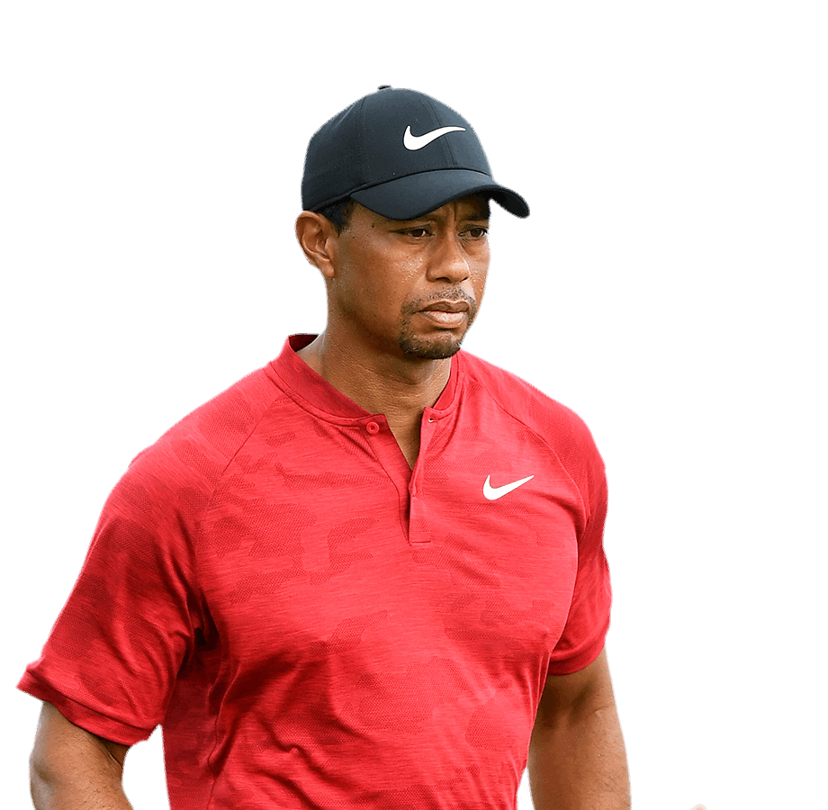
TIGERWOODS

5700 Saddlebrook Way • Wesley Chapel, FL 33544 • 813-555-5555 • yourname@domain.com
ePortfolio Link

Education
Saddlebrook Preparatory School , Wesley Chapel, FL 2017-Present
Class of 2023
GPA: 4.0 SAT Reading: 800 SAT Math: 800 ACT: 36

Previous School, Somewhere, In the World 2016-2017

Tournament Schedule
TOURNAMENT COURSE SCORES RESULT
Saddlebrook Golf Academy
18 years old
1/1/2002
6’1” 187 lbs.
Right-handed
Scoring Average
Drive Average
Coach Mark Hershey
email
2020 Innisbrook Jr. Open Copperhead 72-71-73 T-2
2019 HJGT at Saddlebrook Palmer 70-74-72 3
2018 AJGA Senior Showcase @ Saddlebrook Saddlebrook 71-71-71 T-4
2017 Holiday Classic at Orange County Nat’l National 72-71-70 1

Awards and Achievements
Student of the Month October 2019
Student of the Month Nominee September 2019
National Honor Society 2019-Present
Dean’s List Fall and Spring 2018
Saddlebrook Tennis Academy: Hardest Worker 2018
Outstanding Student: Computer Applications 2018
Dean’s List Spring 2017


TIGER WOODS

CLASS OF 2023

DoB: 1/1/2002, 18 years old
6’1” 187 lbs.
Right-handed
Scoring Average
Drive Average
Coach Mark Hershey email

Education
Saddlebrook Preparatory School, Wesley Chapel, FL 2017-Present
Class of 2023
GPA: 4.0 SAT Reading: 800 SAT Math: 800 ACT: 36

Previous School, Somewhere, In the World 2016-2017

Tournament Schedule
TOURNAMENT COURSE SCORES RESULT
2020 Innisbrook Jr. Open Copperhead 72-71-73 T-2
2019 HJGT at Saddlebrook Palmer 70-74-72 3
2018 AJGA Senior Showcase @ Saddlebrook Saddlebrook 71-71-71 T-4
2017 Holiday Classic at Orange County Nat’l National 72-71-70 1

Awards and Achievements
Student of the Month October 2019
Student of the Month Nominee September 2019
National Honor Society 2019-Present
Dean’s List Fall and Spring 2018
Saddlebrook Tennis Academy: Hardest Worker 2018
Outstanding Student: Computer Applications 2018
Dean’s List Spring 2017

5700 Saddlebrook Way • Wesley Chapel, FL 33544 • 813-555-5555 • yourname@domain.com
ePortfolio Link
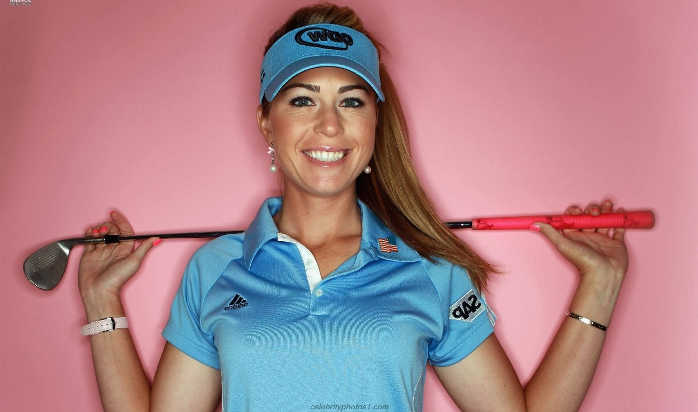
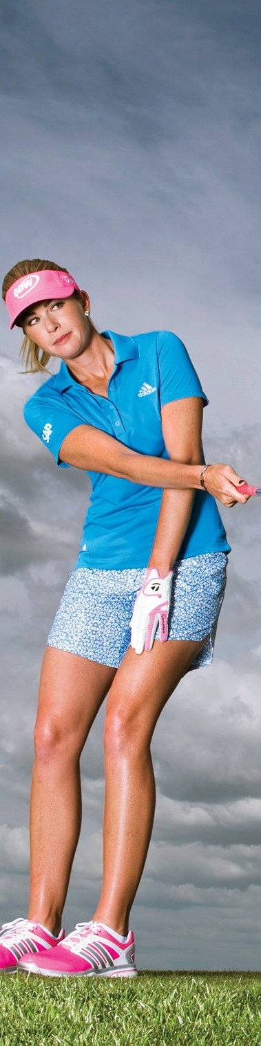
DoB: Jan. 1, 2002; 18 y/o
5’4”
Right-handed
Scoring Average
Drive Average
Coach Mark Hershey email

Paula Creamer

5700 Saddlebrook Way • Wesley Chapel, FL 33544 • 813-555-5555
yourname@domain.com • ePortfolio Link
Education
Saddlebrook Preparatory School , Wesley Chapel, FL 2017-Present
Class of 2023
GPA: 4.0 SAT Reading: 800 SAT Math: 800 ACT: 36

Previous School, Somewhere, In the World 2016-2017

Tournament Schedule
TOURNAMENT COURSE SCORES RESULT
2020 Innisbrook Jr. Open Copperhead 72-71-73 T-2
2019 HJGT at Saddlebrook Palmer 70-74-72 3
2018 AJGA Senior Showcase @ Saddlebrook Saddlebrook 71-71-71 T-4
2017 Holiday Classic at Orange County Nat’l National 72-71-70 1

Awards and Achievements
Student of the Month October 2019
Student of the Month Nominee September 2019
National Honor Society 2019-Present
Dean’s List Fall and Spring 2018
Saddlebrook Tennis Academy: Hardest Worker 2018
Outstanding Student: Computer Applications 2018
Dean’s List Spring 2017

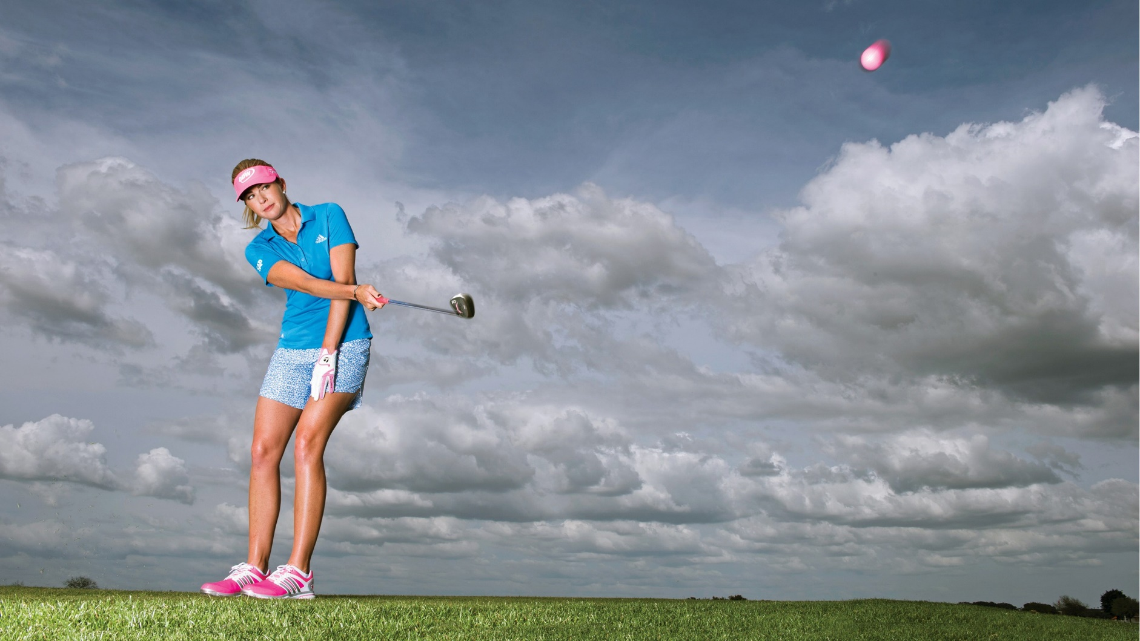
Paula Creamer

5700 Saddlebrook Way • Wesley Chapel, FL 33544
813-555-5555 • yourname@domain.com • ePortfolio Link

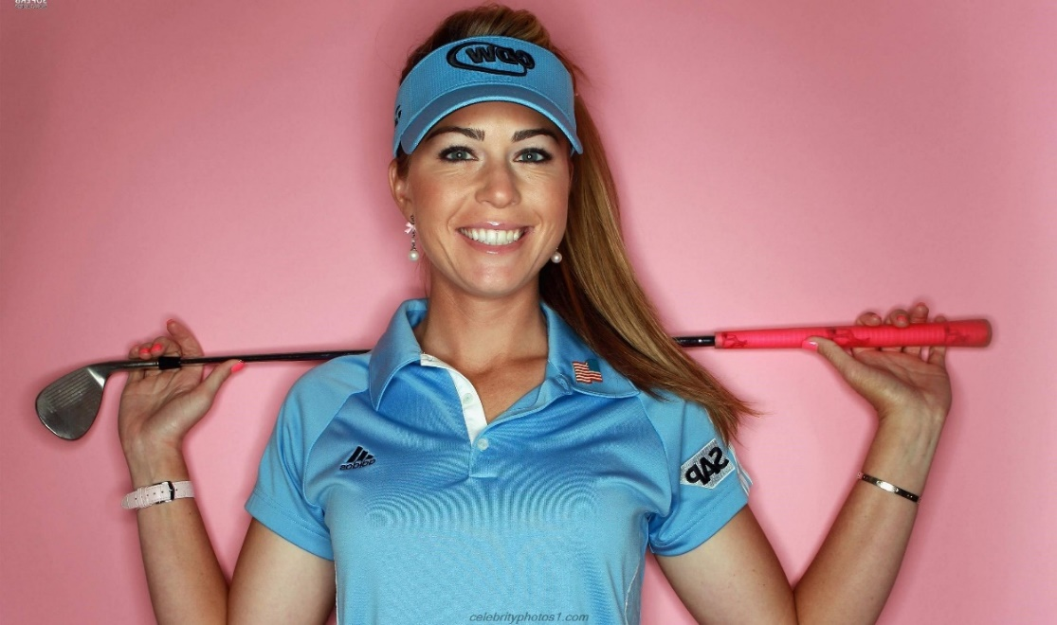

Education
Quickfacts

DoB: Jan. 1, 2002; 18 y/o
5’4”
Right-handed
Scoring Average
Drive Average
Coach Mark Hershey email
Saddlebrook Preparatory School , Wesley Chapel, FL 2017-Present
Class of 2023
GPA: 4.0 SAT Reading: 800 SAT Math: 800 ACT: 36

Previous School, Somewhere, In the World 2016-2017

Tournament Schedule
TOURNAMENT COURSE SCORES RESULT
2020 Innisbrook Jr. Open Copperhead 72-71-73 T-2
2019 HJGT at Saddlebrook Palmer 70-74-72 3
2018 AJGA Senior Showcase @ Saddlebrook Saddlebrook 71-71-71 T-4
2017 Holiday Classic at Orange County Nat’l National 72-71-70 1

Awards and Achievements
Student of the Month October 2019
Student of the Month Nominee September 2019
National Honor Society 2019-Present
Dean’s List Fall and Spring 2018
Saddlebrook Tennis Academy: Hardest Worker 2018
Outstanding Student: Computer Applications 2018
Dean’s List Spring 2018

